Here’s a structured bullet-point summary of Reading 2.4: Serverless and AWS Lambda:
🔹 Removing the Undifferentiated Heavy Lifting
- EC2: AWS manages hardware; you manage OS, security, patching, networking, scaling.
- ECS/EKS on EC2: AWS manages container orchestration, but you still manage EC2 instances.
- Serverless: No EC2 instance management required; AWS handles scaling, availability, and infrastructure.
🔹 Key Aspects of Serverless
- No servers to provision/manage.
- Scales automatically with usage.
- Pay only for active usage (no idle costs).
- Built-in availability and fault tolerance.
🔹 AWS Fargate (Serverless Containers)
- Serverless compute engine for containers.
- Eliminates need to manage EC2 instances or cluster capacity.
- Supports ECS and EKS architectures.
- Provides workload isolation and improved security.
- Integrates natively with IAM and VPC for secure networking.
🔹 AWS Lambda (Serverless Functions)
- Run code without provisioning/managing servers or containers.
- Supports diverse workloads: data processing, real-time streams, ML, IoT, APIs, web apps.
- Zero administration: upload code, Lambda handles scaling and availability.
- Continuous scaling with subsecond metering.
🔹 How Lambda Works
- Three components: trigger, code, configuration.
- Code options:
  - Write from scratch.
  - Use AWS blueprints.
  - Use AWS Serverless Application Repository.
- Supports multiple runtimes: Python, Node.js, Ruby, Go, Java, .NET Core, or custom.
- Configuration includes: network placement, environment variables, memory, permissions, invocation type.
- Triggers integrate with AWS services to run functions in response to events.
🔹 Lambda Function Handler
- Handler processes events when function is invoked.
- General Python syntax:
- 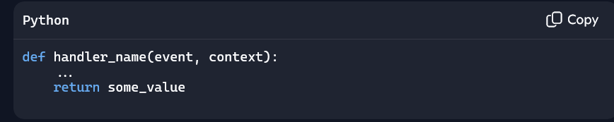
- Default naming: lambda_function.lambda_handler.
🔹 Billing Granularity
- Charged based on:
  - Number of requests.
  - Execution duration (rounded to nearest 1ms).
- No minimum execution time → cost-effective for short-duration functions (<100ms).

